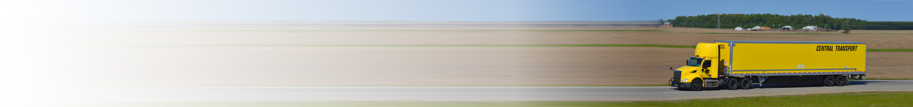

Central Transport New Account Form

12225 Stephens Road

Warren, MI 48089

(586) 939-7000

[***www.centraltransport.com***](http://www.centraltransport.com/)

Credit applications are required for all customers not in the CTII system. Completed forms should be given to your

sales rep for review and submission to the Pricing Department. (Attn Sales Rep: Forms MUST be emailed to

[***creditapp@centraltransport.com***](mailto:creditapp@centraltransport.com) – you must also include the preq # in the subject line)

Company Name

Company Name

Contact Name

Contact Name

Street Address

Street Address

□ YES

□ NO

□ US □CAN □MEX

□ YES

□ NO

□ US □CAN □MEX

Residential?

Residential?

State/Province

State/Province

City

Zip/Postal Code

City

Zip/Postal Code

Phone

Ext

Phone

Ext

Email

Email

General Information:

Federal Tax ID:

Corporation Country

□ US □CAN □MEX

At present location since

State/Province

Dun & Bradstreet #

Credit Amount

Contact Name

Title

Email Address

Phone

Ext

Are you an internet shipper via Craigslist or Ebay? □ YES □ NO

Company Composition? (check) □ INDIVIDUAL □ PARTNERSHIP □ CORPORATION □LLC

□ YES □ NO

Are the premises leased?

Bank Information:

Bank Name

Account Number

Account Type

Bank Address

Branch Name

Bank Contact Officer

City

State/Province

Zip/Postal Code

□ US □CAN

□MEX

Terms & Conditions All invoices are to be paid 15 days from the date of invoice. Claims arising from invoices must be made within seven working days.

By submitting this application, you authorize Central Transport to make inquiries into the banking and business/trade references that you have supplied.

I agree to the terms as stated above. Customer Signature:

Date:

ACCEPTANCE AND APPROVAL (Office use only):

NAME:

DATE:

APPROVED CREDIT LIMIT:

MM/DD/YYYY

Billing Address: Office/Shipping Address (if different than billing address):